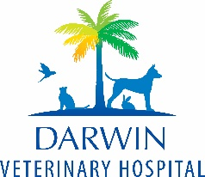
What Darwin has to Offer!
🌅 Natural Beauty, Beaches & Waterfront Life
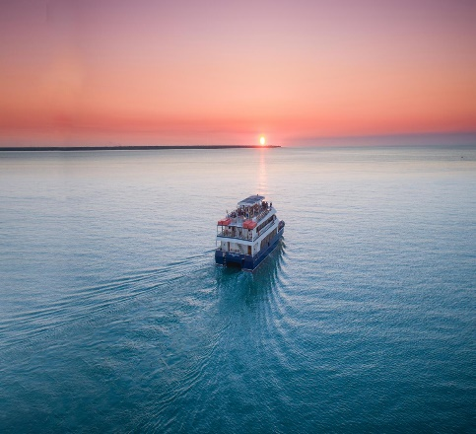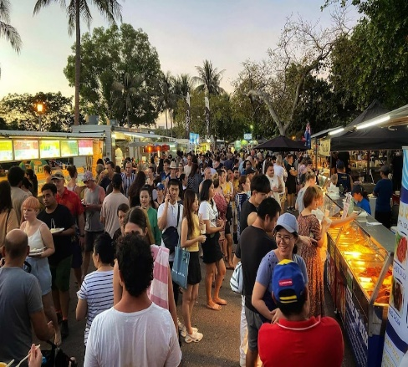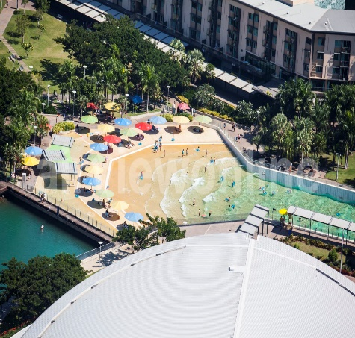
- Darwin Harbour & waterfront — Darwin Harbour offers sailing, fishing, turtle-watching, birdwatching, scenic harbour cruises and relaxing harbour-front strolls.
- Mindil Beach & the Mindil Beach Sunset Markets — Held on Thursday and Sunday evenings (during dry season), the sunset markets bring art, crafts, street food, live music and a vibrant atmosphere against stunning beach sunsets.
- Relaxing & waterside fun — The waterfront area (often just called “The Waterfront”) is great for a swim or chill-out break; it’s a nice mix of water, harbour views and relaxed urban vibes.
🐊 Wildlife & Adventure — Crocs, Reptiles, Wetlands
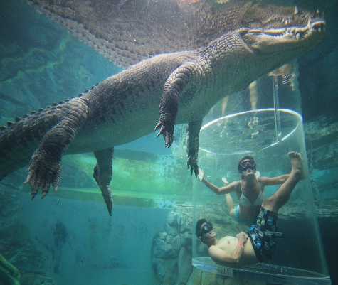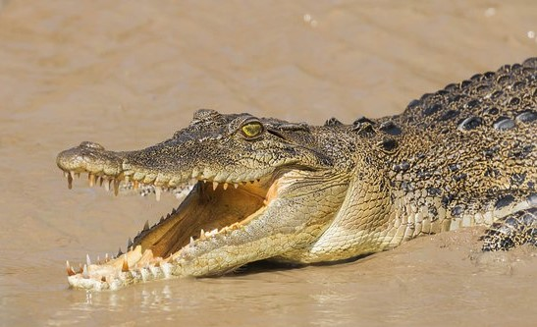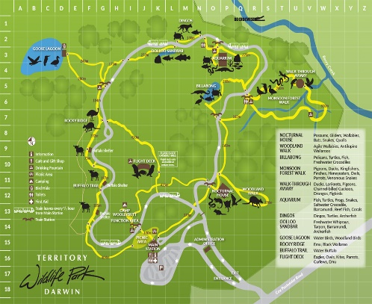
- Crocosaurus Cove — Right in the city; it’s home to Australia’s largest reptile display. You can see huge saltwater crocodiles, native reptiles and fish, and even experience the adrenaline-fueled “Cage of Death” crocodile dive.
- Wildlife & Nature excursions around Darwin — If you’re up for venturing outside the city, there are wetlands, waterholes and national-park-style areas nearby where you might see crocodiles, birds and other native species.

🎨 Culture, History & Local Life
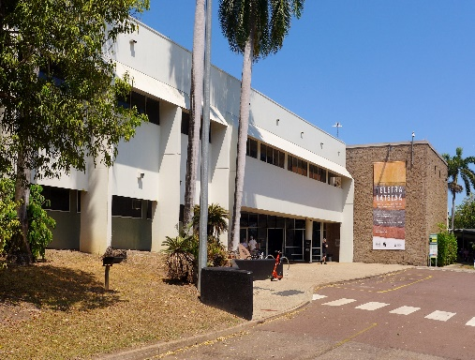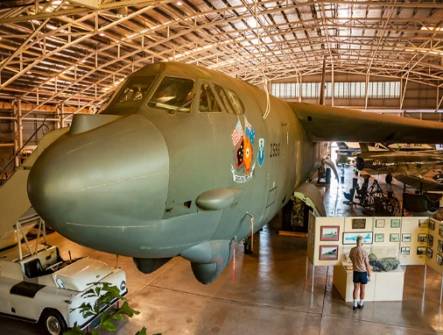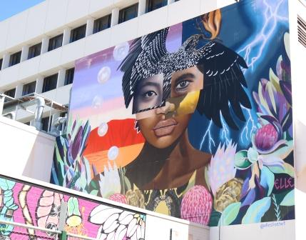
- Museum and Art Gallery of the Northern Territory (MAGNT) — A must-visit for culture lovers. It features Aboriginal art, artifacts, natural history, and exhibits that tell Darwin’s story — including impactful moments like the wartime bombings and local heritage.
- Wartime history at Darwin Military Museum — This museum offers WW2 history, including exhibits about Darwin’s role during the war, and is ideal for history buffs.
- Local arts, crafts, shopping & Aboriginal culture — The city has galleries, Aboriginal-art outlets and local-style boutiques. For a dose of local colour, the markets, galleries and shopping areas are worth a wander.
🚤 Day Trips & Excursions — Beyond the City
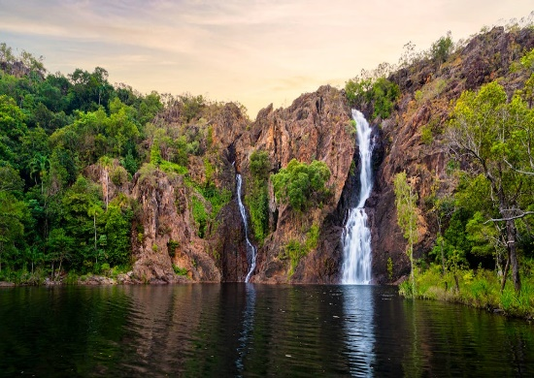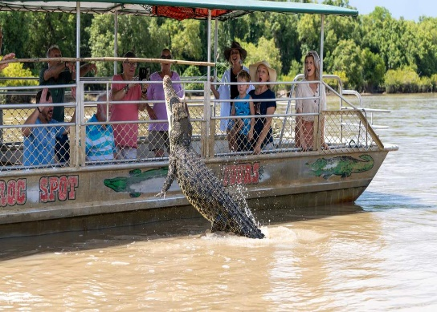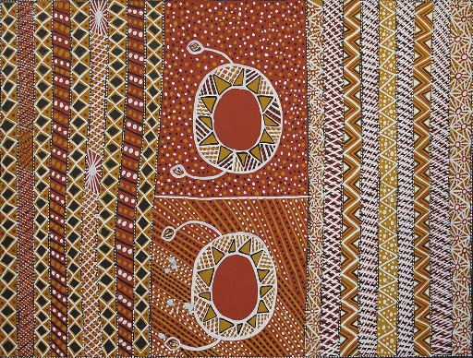
- Nearby natural escapes — Darwin is a great base for exploring surrounding nature: wetland cruises, wildlife-filled wetlands and national-park areas make for memorable day trips.
- Cultural out-of-town adventures — From Indigenous art and cultural experiences to exploring remote natural beauty, trips beyond the city offer a different side of the Top End.
🎯 What’s Great About Darwin Overall
- Blend of urban comfort and wild frontier — You get a relaxed city vibe, but you’re never far from wild landscapes, nature and adventure.
- Rich mix of culture, history & Aboriginal heritage — Between art galleries, museums and cultural sites, Darwin has a layered and meaningful story to tell.
- Access to both harbour and outback-style natural wonders — Beaches, wetlands, wildlife, national-park escapes — Darwin offers a bit of everything.
- Easy-going lifestyle & relaxed pace — Whether you want to chill by the water, stroll markets, or enjoy a sunset cruise, Darwin tends to move at its own leisurely rhythm.

